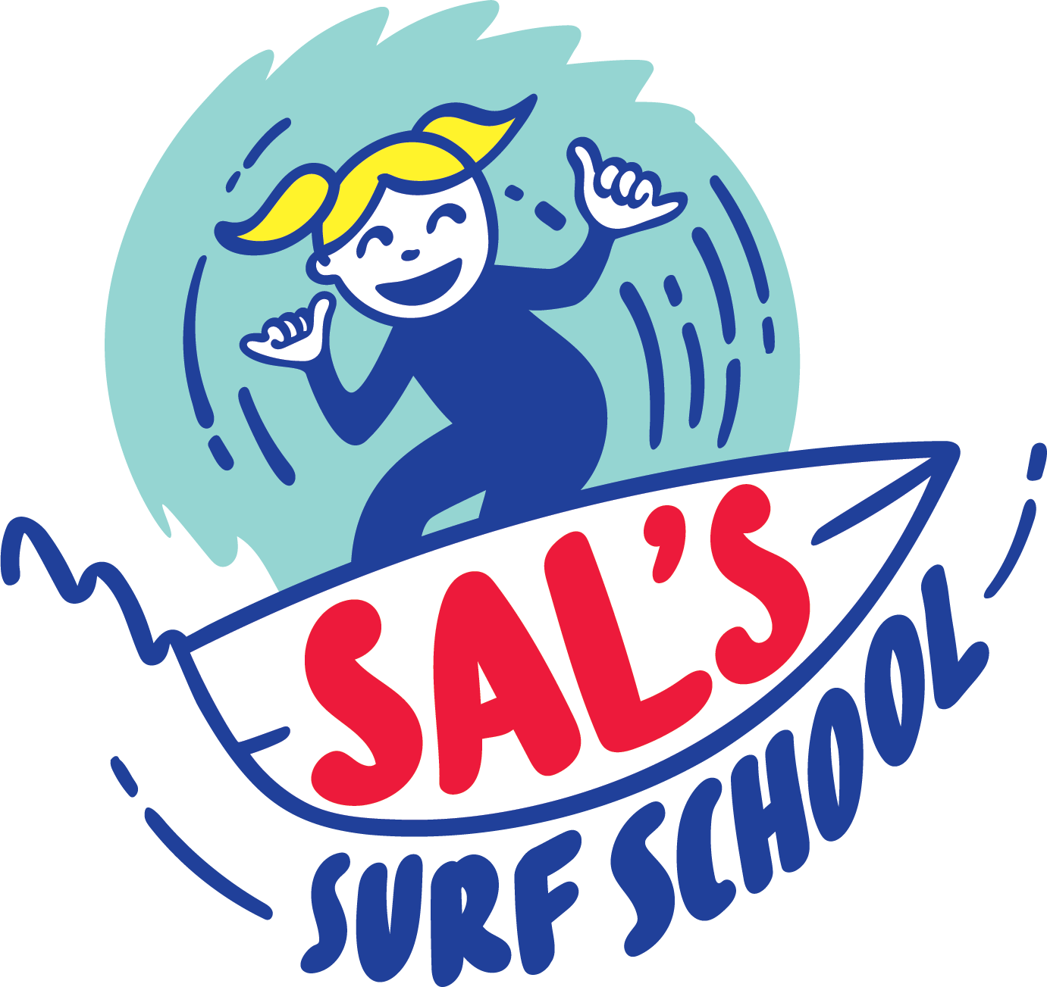

SURFING PROGRAM PARTICIPANT DECLARATION Indemnity Sign on Waiver form
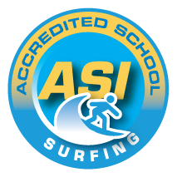

Surf School Name: Sal’s Surf School

In consideration of the Surf School accepting my application to participate in the Program, below

I acknowledge, understand and agree that:

- “Surf School” for the purposes of this declaration means and includes the nominated accredited surf school, Academy of Surfing Instructors ("ASI"), and their respective directors, officers, members, servants or agents.
- There is a condition called Surfers Myelopathy that can result in paralysis below the waist. It is extremely rare and appears to result when the spine is arched. It is not conclusive who may be affected, although cases have been in adults. Prior to onset, legs may feel weak, there is back or leg pain or discomfort, possible tingling may occur with the discomfort and pain intensifying. Any of these symptoms should be immediately reported to the surfing instructor during the surf lesson.
- Warning: I understand and acknowledge that surf activities are dangerous and there are inherent risks which may result in serious injury to myself. Additionally, waves/ocean can act in a sudden and unpredictable (changeable) way.
- I declare that I can swim 50 metres (150 feet).
- I declare that I do not have any fitness, medical or physical conditions that would affect my participation in the activity. (e.g. please advise instructor of asthma, previous broken bones, dislocated joints, diabetes, allergic reactions, wear contact lenses/hearing aids, any disabilities, etc.)
- I agree not to drink alcohol or take prohibited drugs before or during surf activities.
- I will at all times comply with the instructions and safety procedures of the Surf School.
- I authorise the Surf School to arrange medical or hospital treatment as necessary and I agree to pay for all associated costs.
- Photographic and or visual images taken by the Surf School of my participation in the Program may be used for general promotion of the Organiser's activities.
- I understand that the information provided by me in this form is necessary for the operation of the Program. I acknowledge and agree that the information will only be used for the objects of the Surf School and to provide me with information pertaining to the Program. I understand that I will be able to access my information through the Surf School upon request. If the information is not provided I might not be permitted to participate in the Program.
- I ACCEPT THE RISKS INVOLVED and will be responsible for my own actions and /or involvement. Release and Indemnity: I understand that my signature to this document constitutes a complete and unconditional release or all liability of the proprietors of the Surf School and its employees and agents to the greatest extent allowed by the law in the event of me and/or the children under my care, suffering injury or death.
- I declare that I do not have cold or flu symptoms or been in contact with anyone who has been overseas recently or returned a positive test for COVID19
- I declare that I will follow all COVID19 safety measures set out by Sals Surf School and practice social distancing where possible and good hygiene

I have read, understood, acknowledge and agree to the above declaration including the warning, release and indemnity.
Name: ___________________________________________________________Male/Female ___________ Age: ____________
E-Mail: ______________________________________________ Contact No: _________________________
Address: _______________________________________________________ Post Code: ___________
SURFER’S MEDICAL INFORMATION (confidential). Please indicate any medical conditions that coaches should be aware of:

Signed: Date:
Where the applicant is under 18 years of age this form must also be signed by the applicant’s parent or legal guardian.
I,__________________________________________ am the parent or guardian of the applicant. I expressly agree to be responsible for the applicant’s behaviour and agree to personally accept the conditions set out in this application and declaration including the provision by me of a release and indemnity in the terms set out above.

Parent’s signature:__________________________________ Date:

